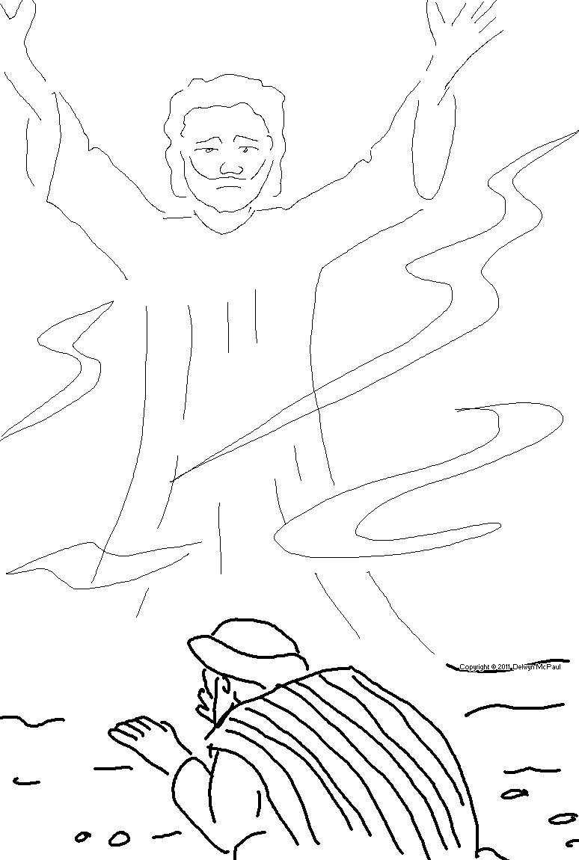
The _ _ _ _ _ _ at least know they will die, but the _ _ _ _ know nothing. Ecclesiastes 9:5 _{NLT}

